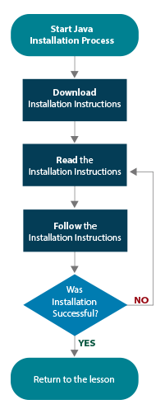
Java Installation and Setup for Windows
An overview of Java installation process is illustrated in the flowchart. If you have read through the instructions, you are ready for Step 4.

Follow the directions below very carefully. Java installation and setup will not go smoothly if you rush through the process and overlook important details. You may want to check off each stage in the flowchart as it is completed.
Update 221 was the latest version of Java 8 at the time these instructions were written. Don’t be surprised if there is something more recent now. Just substitute the number of the current release anywhere you see references Update 221 in these directions.

You should already have a basic knowledge of how to download files and create folders on your computer. If you do not, consult the Windows Help menu and learn the details you don’t know.

Every computer is different, so don’t be surprised if during the installation and setup process you have to make some minor adjustments. In those situations, simply accept any default choices that Windows makes for you.

Step 1: Download Java

- Go to the Java website: https://www.java.com/en/download/

- Choose Java Download.

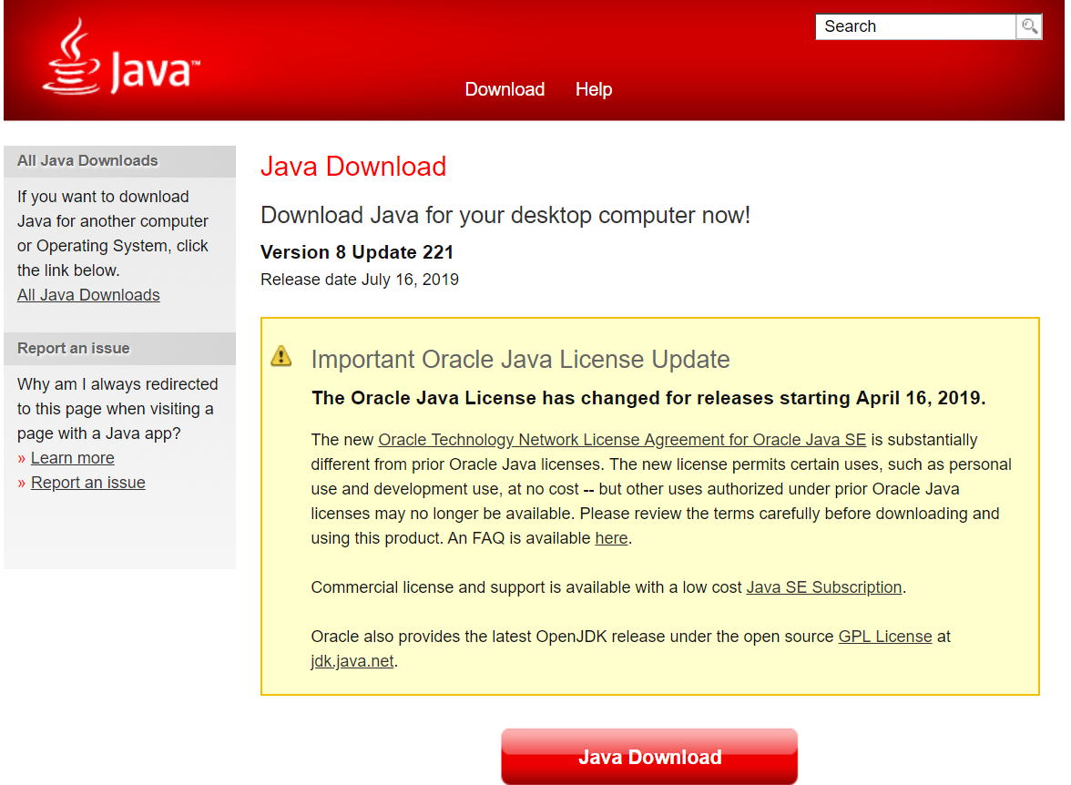

- Accept the License Agreement and choose Agree and Start Free Download.

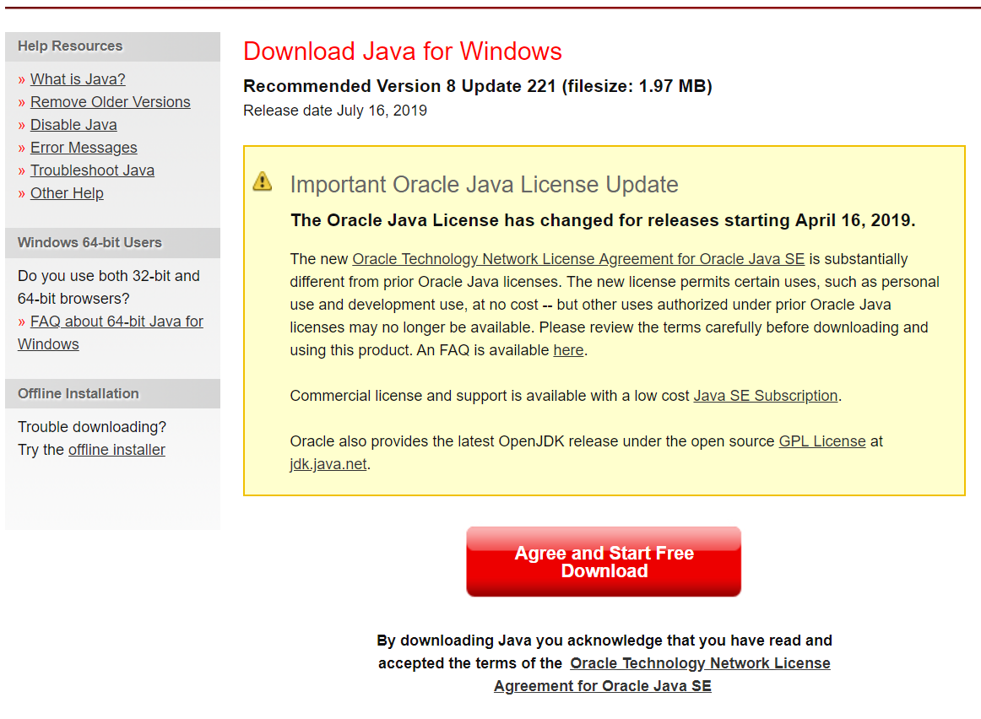

- Open the JavaSetup8u221.exe file to begin the download process.

Step 2: Installing Java for the Windows Operating System

- Choose Install.

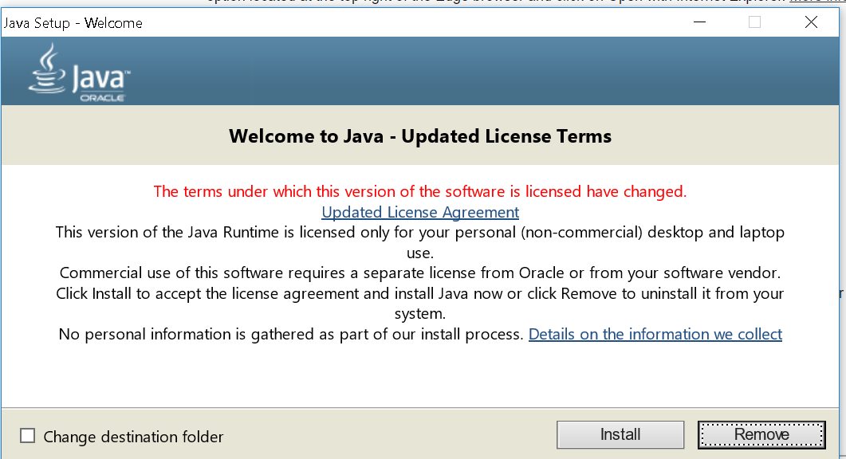

- The Installer will launch and take over. Its progress will be shown.

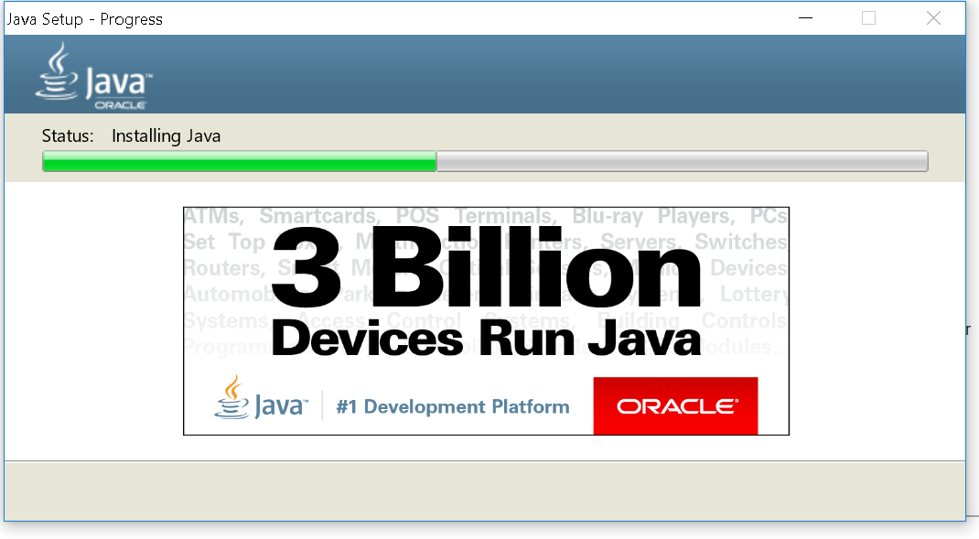

- If there is a previous version of Java installed on the computer, choose Uninstall.

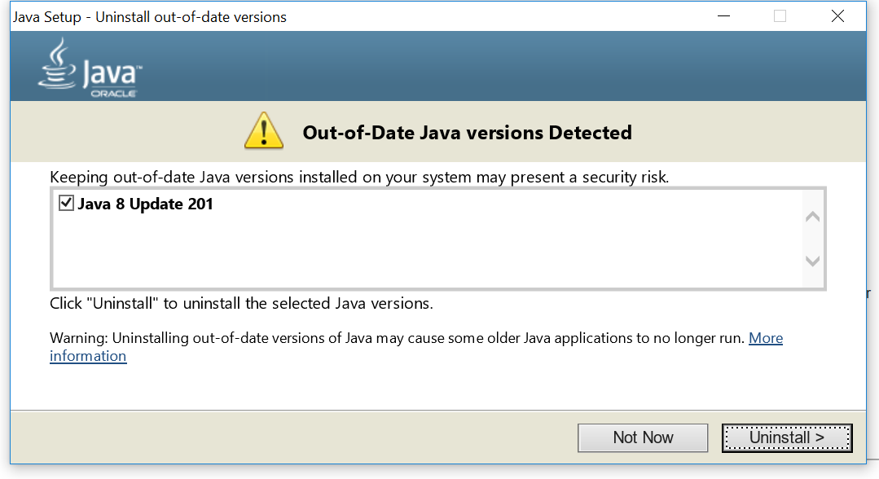

- Installation complete.

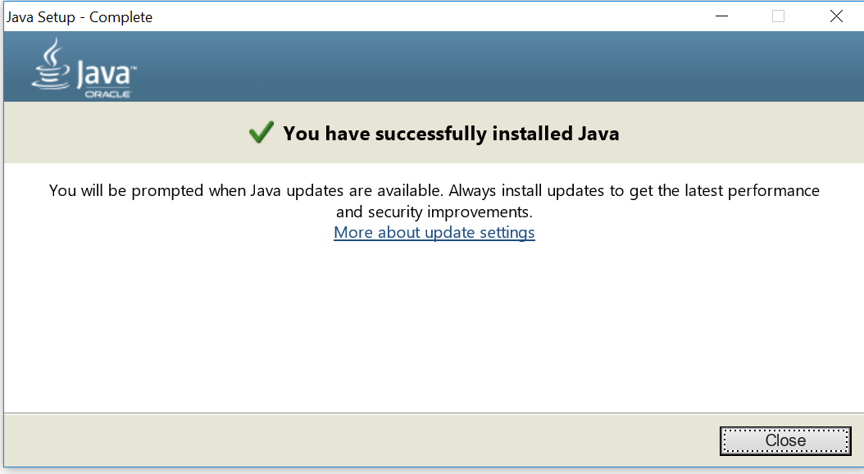

If you have set up your Java environment correctly, you are now ready to install BlueJ. After that, you can begin writing programs.

Sometimes installation and setup are not successful on the first attempt. If that happens to you, please re-read the instructions carefully and try again. After a second unsuccessful attempt, please contact your instructor for additional assistance.

